**iPhone SE**

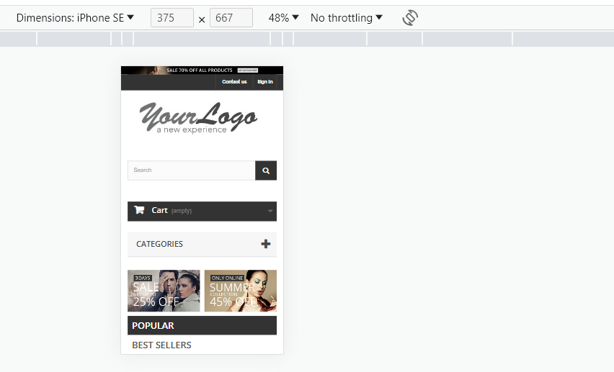

**iPhone XR**

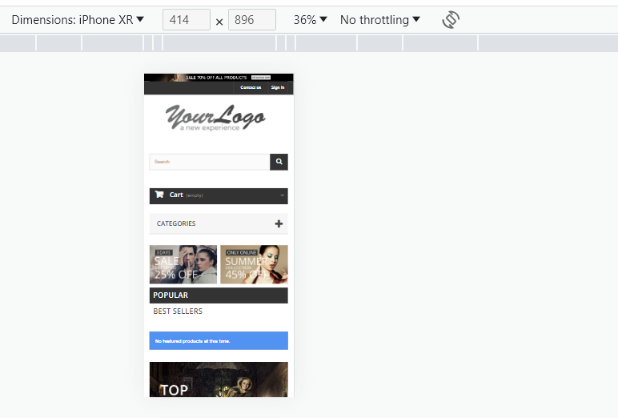

**iPhone 12 Pro**

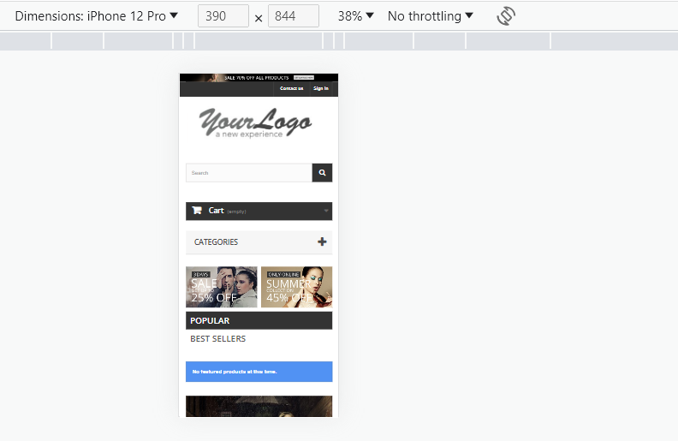

**Pixel 5**

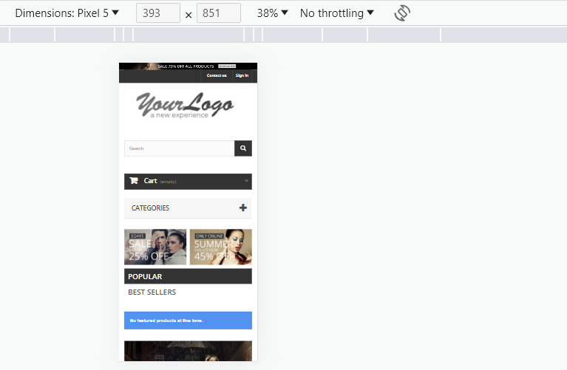

**Samsung Galaxy S8+**

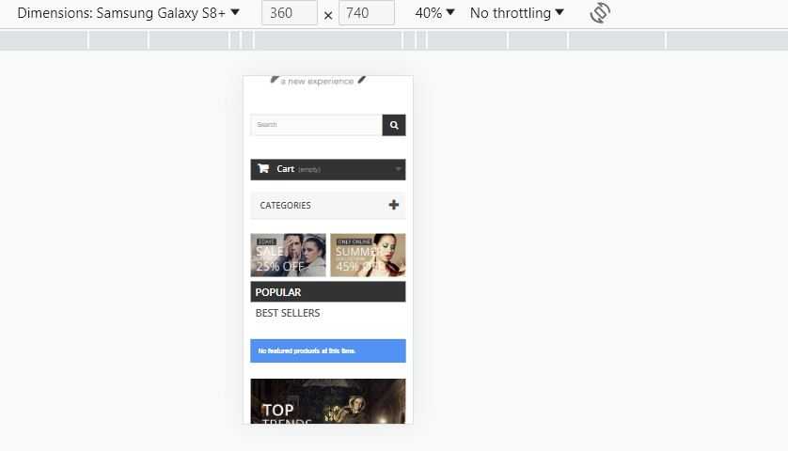

**Samsung Galaxy S20 Ultra**

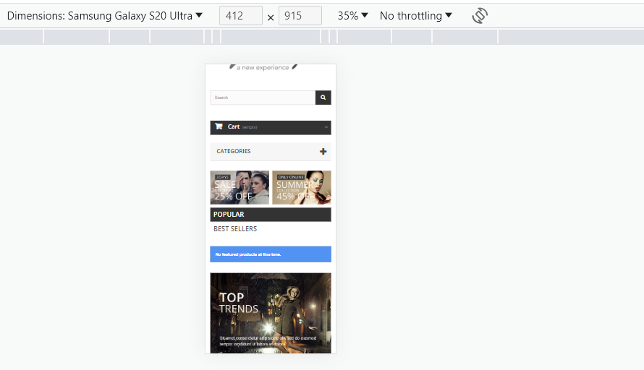

**iPad Air**

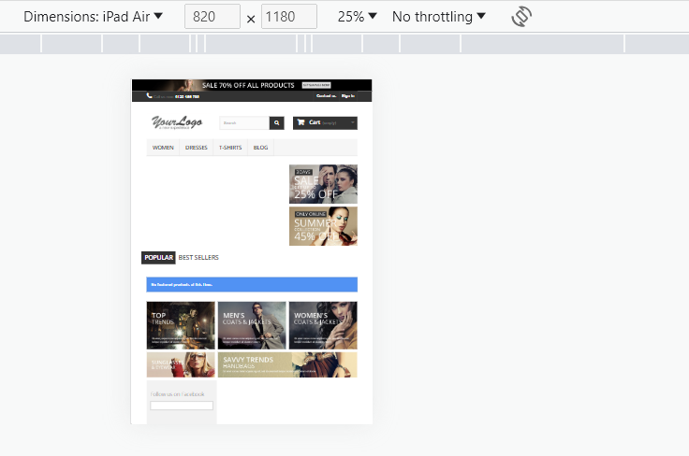

**iPad Mini**



**Surface Pro 7**

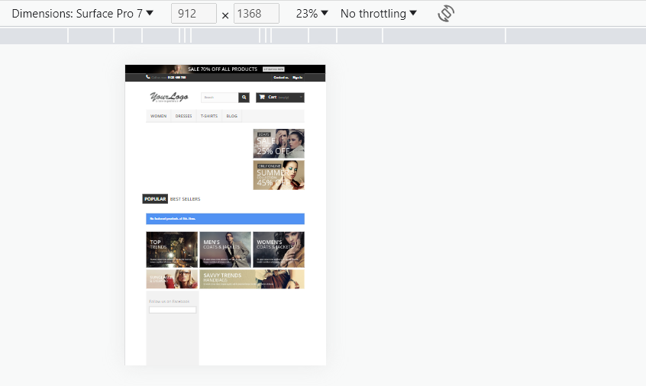

**Surface Duo**

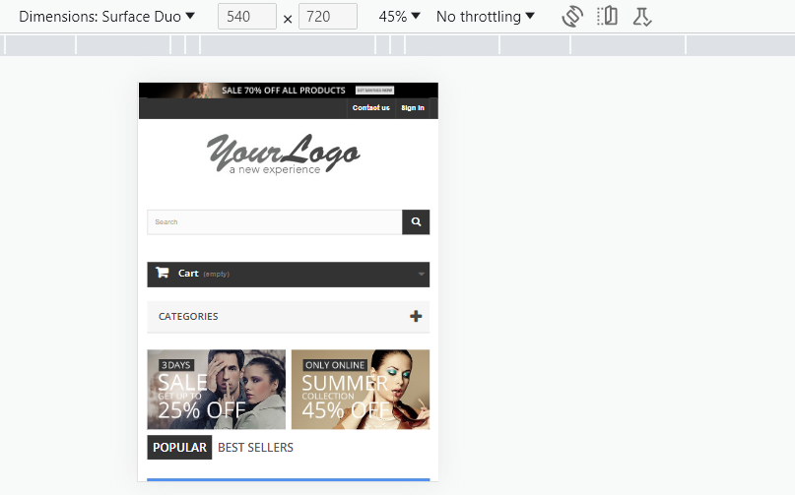

**Galaxy Fold**

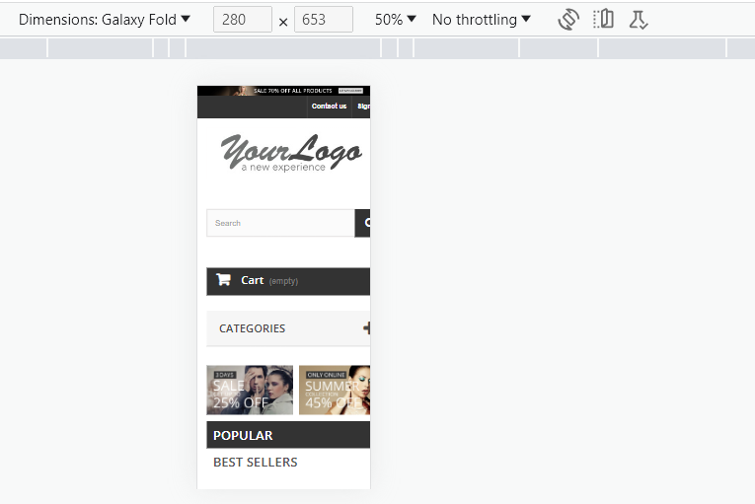

Website does not fit properly, in Galaxy Fold

**Samsung Galaxy A51/71**

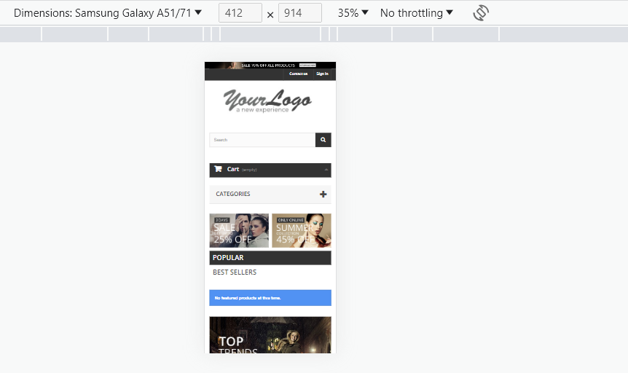

**Nest Hub**



**Nest Hub Max**

